**EAST WEST UNIVERSITY**

**LAB – 1**

**The Bisection Method**

**Course Code: ICE470**

**Course Title: Applied Numerical Methods**

**Section – 01**

**Submitted To:**

Muhammad Suhail Najeeb  
Lecturer

Dept. of ECE

East West University

**Submitted By:**

MD Imran Ahmed

ID: 2015-2-50-018

**Date of Submission**: 17-06-2019

**Objective**: Applying Bisection method to obtain the root of the function

f(x) = x^3 – 6x^2 +4x + 12

**Software Tools:** MATLAB

**Bisect function :**

function r = bisect(x1,xu,es,imax, func)

iter = 0;

ea = 10000; %approximate error

xr = x1;

fprintf('iter \t x1 \t xu \t xr \t ea');

while(ea> es || iter<= imax)

xr_old = xr;

xr = (x1+xu)/2;

iter = iter+1;

if(xr ~= 0)

ea = abs((xr - xr_old) / xr) * 100;

end

fx1 = feval(f,x1);

fxr = feval(f,xr);

test = fx1*fxr;

if(test < 0)

xu = xr;

elseif(test > 0)

x1 = xr;

else

ea = 0;

end

fprintf(' %d \t %f \t %f \t %f \t %f \n', iter,x1,xu,xr,ea);

end

r = xr;

end

**Plot Function:** Plot the functionf(x) = x^3 – 6x^2 +4x + 12 using the bisect function to find the root

**Code**:

func = @(x) x.^3 - 6* x.^2 + 4*x + 12;

x = -2:0.1:6;

y = feval(func,x);

plot(x,y);

xlabel('x');

ylabel('y');

grid on;

x1 = -2;

xu = 6;

es = 0.01;

imax = 20;

r = bisect(x1,xu);

disp(r);

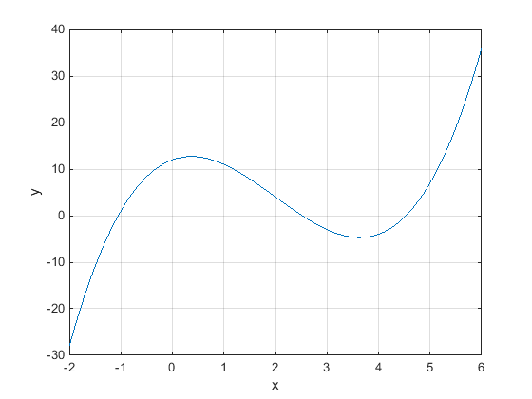

**Bisect function for function:**  f(x) = x^3 +5x^2 +7x + 2

function r = bisect_for_function_2(x1,xu,es,imax, func)

iter = 0;

fx1 = feval(f,x1);

ea = 10000;

xr = x1;

fprintf('iter \t x1 \t xu \t xr \t ea');

while(ea> es || iter<= imax)

xrold = xr;

xr = (x1+xu)/2;

iter = iter+1;

if(xr ~= 0)

ea = abs((xr - xrold) / xr) * 100;

end

%fx1 = feval(f,x1);

fxr = feval(f,xr);

test = fx1*fxr;

if(test < 0)

xu = xr;

elseif(test > 0)

x1 = xr;

fx1 = fxr;

else

ea = 0;

end

fprintf(' %d \t %f \t %f \t %f \t %f \n', iter,x1,xu,xr,ea);

end

r = xr;

end

**Plot the function:** f(x) = x^3 +5x^2 +7x + 2

func = @(x) x.^3 + 5* x.^2 + 7*x + 2;

x = -2:0.1:6;

y = feval(func,x);

plot(x,y);

xlabel('x');

ylabel('y');

grid on;

x1 = -2;

xu = 6;

es = 0.01;

imax = 10;

r = bisect_for_function_2(iter,x1,xu,xr,ea);

disp(r);

**Output:**

es =    0.0100  
  
iteration xl xu xr ea

1 -2.000000 6.000000 2.000000 0.000000   
2 -2.000000 6.000000 2.000000 0.000000   
3 -2.000000 6.000000 2.000000 0.000000   
4 -2.000000 6.000000 2.000000 0.000000   
5 -2.000000 6.000000 2.000000 0.000000   
6 -2.000000 6.000000 2.000000 0.000000   
7 -2.000000 6.000000 2.000000 0.000000   
8 -2.000000 6.000000 2.000000 0.000000   
9 -2.000000 6.000000 2.000000 0.000000   
10 -2.000000 6.000000 2.000000 0.000000   
11 -2.000000 6.000000 2.000000 0.000000   
     2

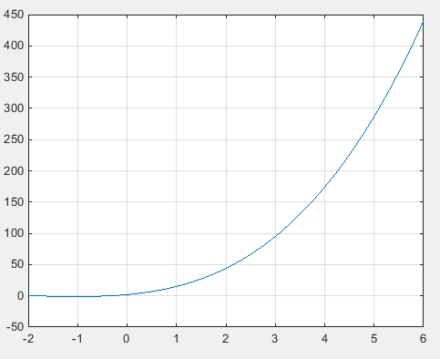

**Discussion:**

We were given two initials XL and XU that contains a root. The bisection method will cut the interval into 2 halves and check which half interval contains a root of the function. The bisection method will keep cut the interval in halves until the resulting interval is extremely small. Finally the root is then approximately equal to any value in the final interval which is very small. Here root value for the function f(x) = x^3 – 6x^2 +4x + 12 would be less than -2.